Big Mountain Resort wants to explore market data for increased value in their ticket price and potentially reduce costs to help offset a $1.54 million rise in operating costs. The objective was to analyze data from 300 resorts that fit into the same market and identify key factors to support increasing the ticket price and cost-saving opportunities for the season.

For this analysis market data was provided on 300 ski resorts throughout the US with amenities consistent with Big Mountain. This data was blended with data that contained population and state sizes sourced from Wikipedia.

With the blended data set of ratios were made to explore the data on a state by state basis. A heat map was created to find correlations between amenities for the in market resorts. These correlations were used to find links to our target feature, the ticket price. These scatter plots were used to verify the relationships.

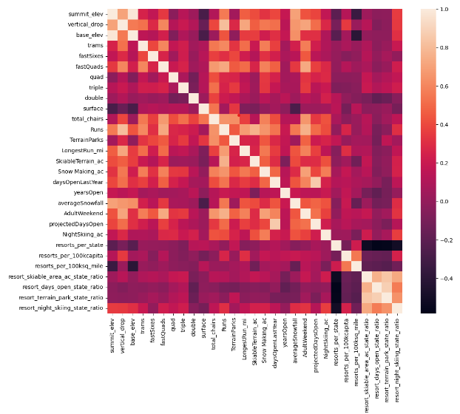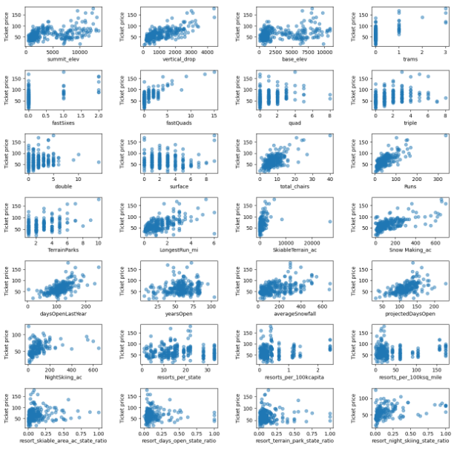

The training of the machine learning model was done step by step with careful consideration to the accuracy and usefulness of the output. The model was designed to replace missing values with the mean, scale all data, and supply random states for consistent learning from the data. The Random Forest Regressor model resulted in the least amount of error, it was chosen for this reason.

During the modeling Big Mountain Resort was removed from the data set to gain a more accurate result. Four scenarios were modeled.

Scenario 1. Permanently closing down up to 10 of the least used runs. This scenario showed closing one run made no difference in the ticket price, but after that the support for an increased ticket price diminished with every closed run.

Scenario 2. Increase the vertical drop by adding a run to a point 150 feet lower down but requiring the installation of an additional chair lift to bring skiers back up, without additional snow making coverage. This scenario had an interesting result, it showed support for raising the ticket price by $9.13. With a seasonal revenue increase of $15,978,514.

Scenario 3. Same as number 2, but adding 2 acres of snow making cover. This scenario showed support for a $10.42 increase per ticket. With a seasonal revenue increase of $18,235,761. A relatively small increase over scenario 1 for what could be costly to operate.

Scenario 4. Increase the longest run by 0.2 mile to boast 3.5 miles length, requiring an additional snow making coverage of 4 acres. This scenario supported a $0.0 ticket price increase.

To get the largest revenue increase I recommend scenario 2 and scenario 3. Also closing one run from scenario 1 would help in lowering operating costs without hurting the ticket price.

More data on operating costs from the market would assist in decision making. I think this is only half the story.